TEEN DRIVING IMPACT PANEL INSTRUCTION SHEET

You have been Court ordered to complete the Cherokee County Juvenile Court Teen Driving Impact Panel. Failure to complete the program will result in a six (6) month suspension of your driver’s license. The cost of the panel is $75.00.
If you were not registered in the court room, then you will need to contact April Timms and get registered for the next available class. It is recommended you register as soon as you are able to, as spots fill up quickly. Registration is completed through April Timms, Juvenile Court Program Manager altimms@cherokeecountyga.gov. Email is the preferred and quickest way to reach Ms. Timms, although you can leave a message at 678-493-6256. Paying for the class is NOT registering for the class and does NOT guarantee a spot for a particular date.
The panel will be held at the:

Roger Garrison Law Enforcement Training Center
516 Chattin Drive
Canton, GA 30115
(Please park in the back of the building)

The panel will be held from 9 a.m. until approximately 12:30 p.m. Sign-in will begin at 8:45 a.m. Although it is not mandatory for parents to attend the panel, they will be allowed to attend with you at no additional cost.
You must attend the entire Teen Driving Panel, there will be NO partial credit. Late arrivals will be denied entry, absolutely no exceptions. Court dress code enforced and appropriate jeans are acceptable.
Upon completion of the panel, you will be presented with a certificate of completion. DO NOT lose your certificate, as only ONE will be issued. You will present the certificate, the $75.00 fee, and the fine in person to the Cherokee County Clerk of Court on the ground floor of the Cherokee County Justice Center during regular business hours. Cash or money order only. Officers will NOT take money at the class.

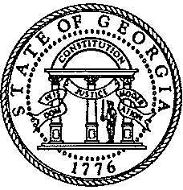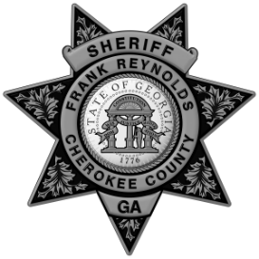
Cherokee County Juvenile Court Cherokee County Sheriff’s Office
Blue Ridge Judicial Circuit

