TEEN DRIVING IMPACT PANEL REGISTRATION FORM
DATE OF PANEL: _________________________________
Youth’s Information
Name: ________________________________________________________
DOB: ________________________________________________________
Phone: ________________________________________________________
Email: ________________________________________________________
Address: ________________________________________________________
Parent/Guardian Information
Name: ________________________________________________________
Phone: ________________________________________________________
Email: ________________________________________________________
Address: ________________________________________________________ Any information you feel we should know about your child:
_______________________________________________________________________________________________________________________________________________________________________________________________________________________________________
Other
*Once form is completed, please email to altimms@cherokeecountyga.gov – court staff will be contacting you with available class dates and to complete your registration. For questions or concerns, please contact April Timms at (678) 493-6256 or altimms@cherokeecountyga.gov

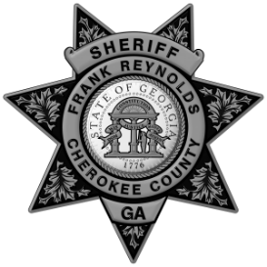
Cherokee County Juvenile Court Cherokee County Sheriff’s Office
Blue Ridge Judicial Circuit

